Installation steps

1. Download the “FlightManagementSystem” file and place it in a directory of your choice.

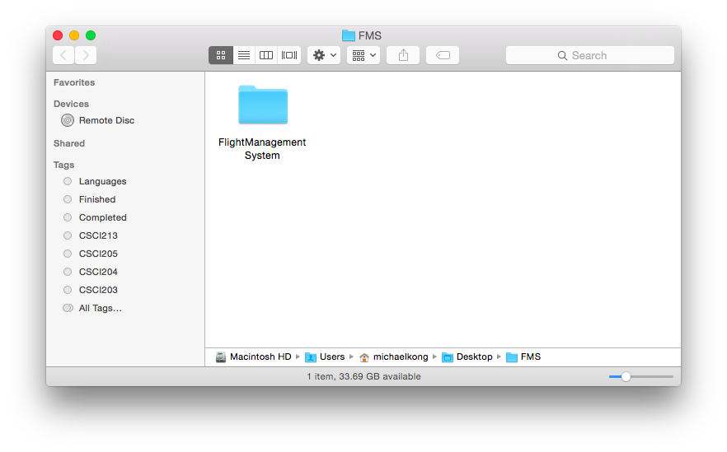

2. Open “Terminal” on UNIX systems or “Command Prompt” in Windows systems. Then navigate to the directory that you placed the “FlightManagementSystem” file in.

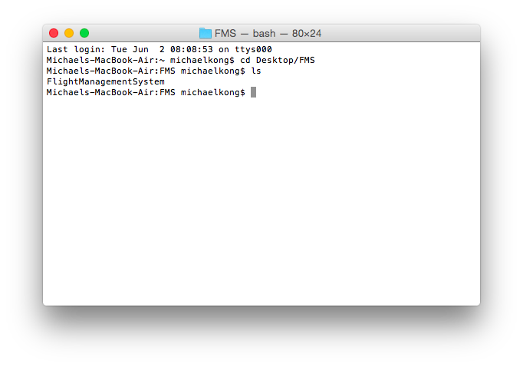

3. Navigate into the FlightManagementSystem folder and execute the following command:

$ make

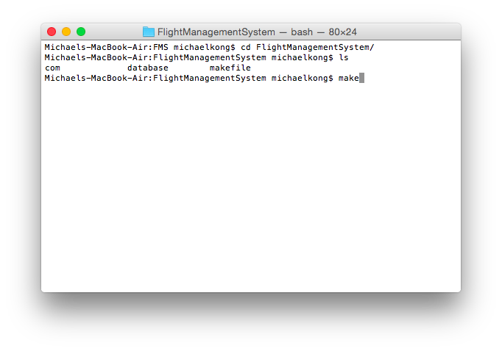

4. The Flight Management System should start running.

